1. Try Test-Connection and nslookup commands for below websites

www.google.com

www.facebook.com

www.amazon.com

www.github.com

[www.cisco.com](http://www.cisco.com)

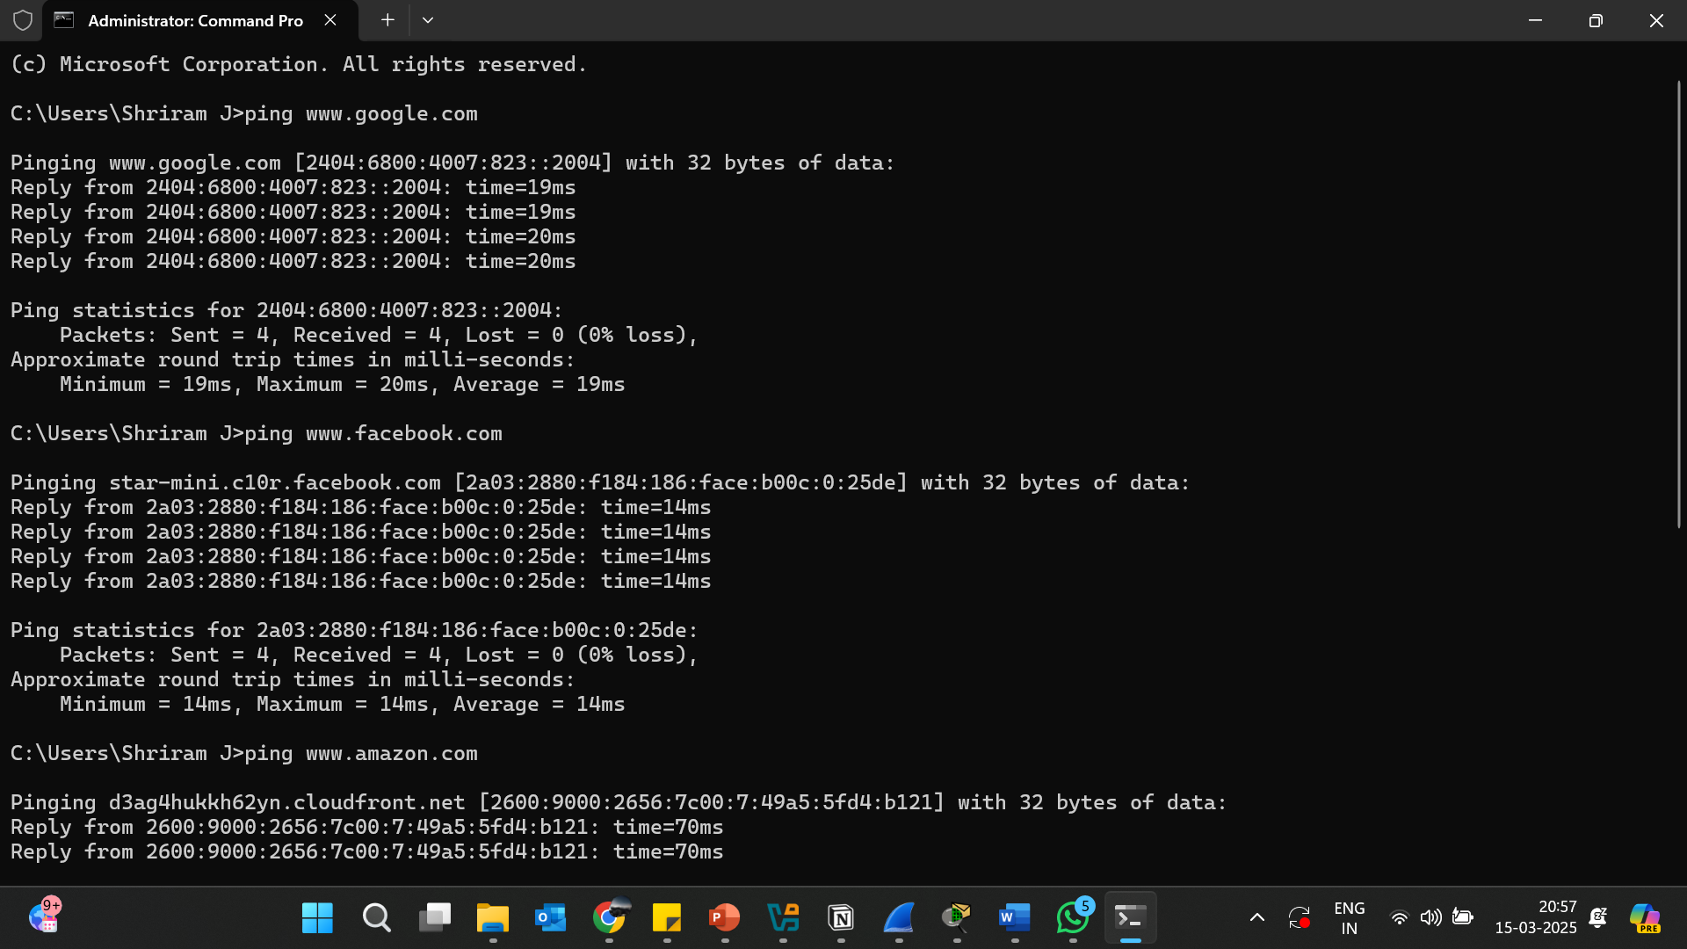

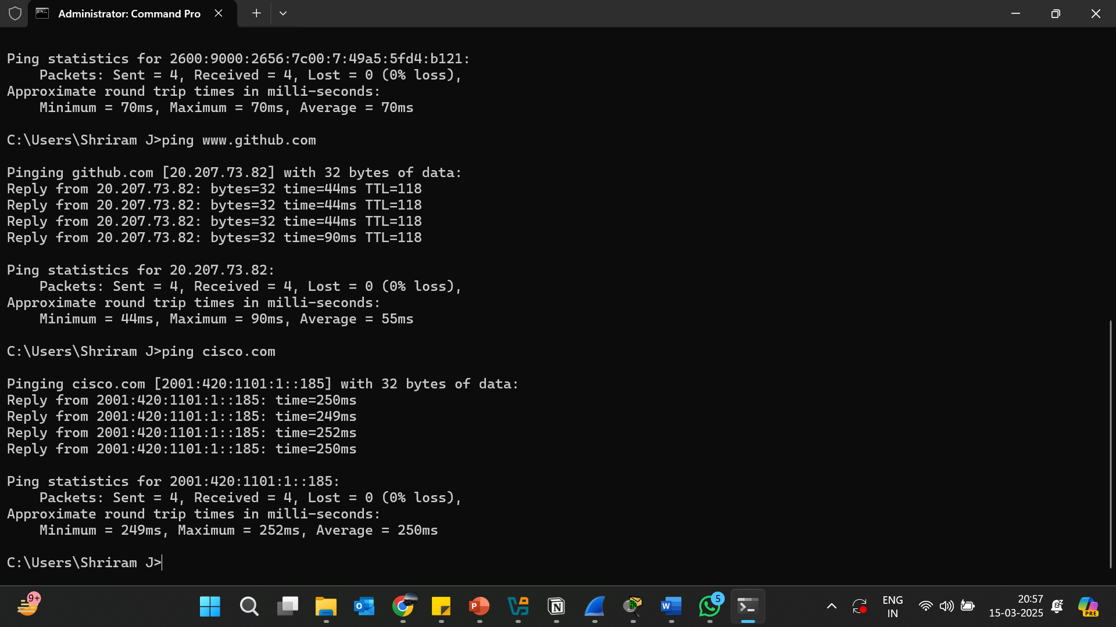

NS LOOKUP COMMAND:

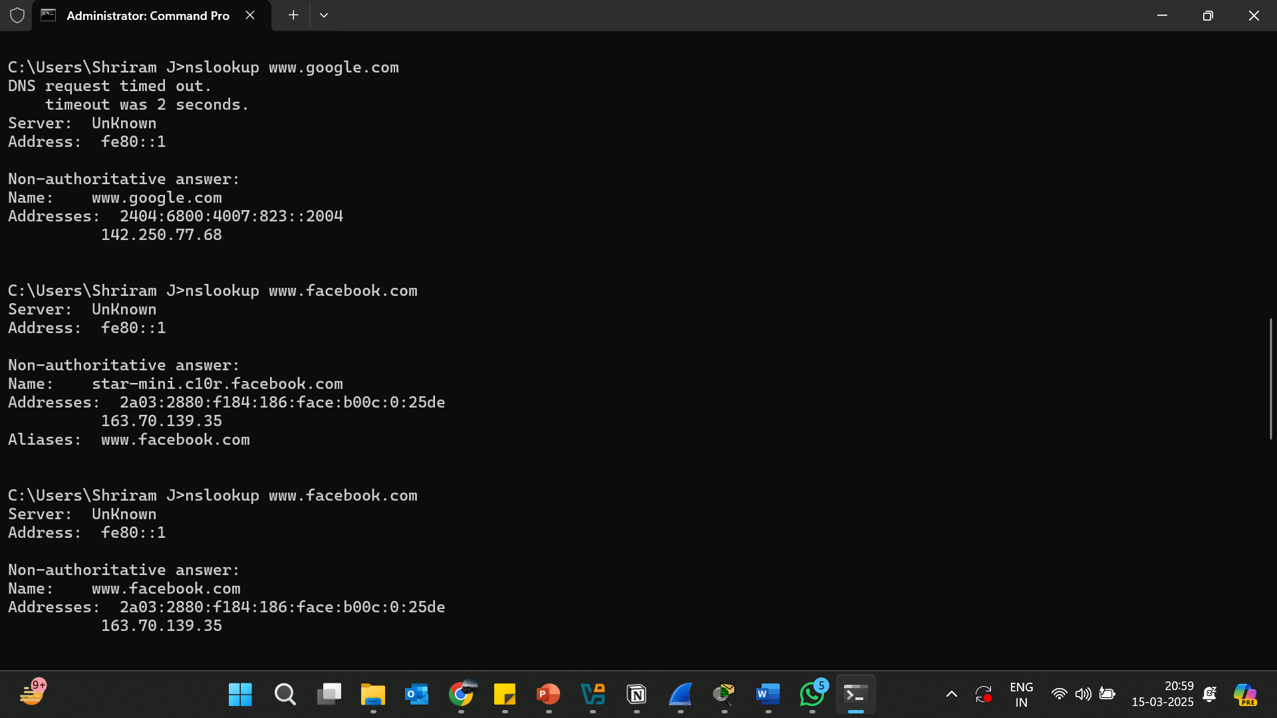

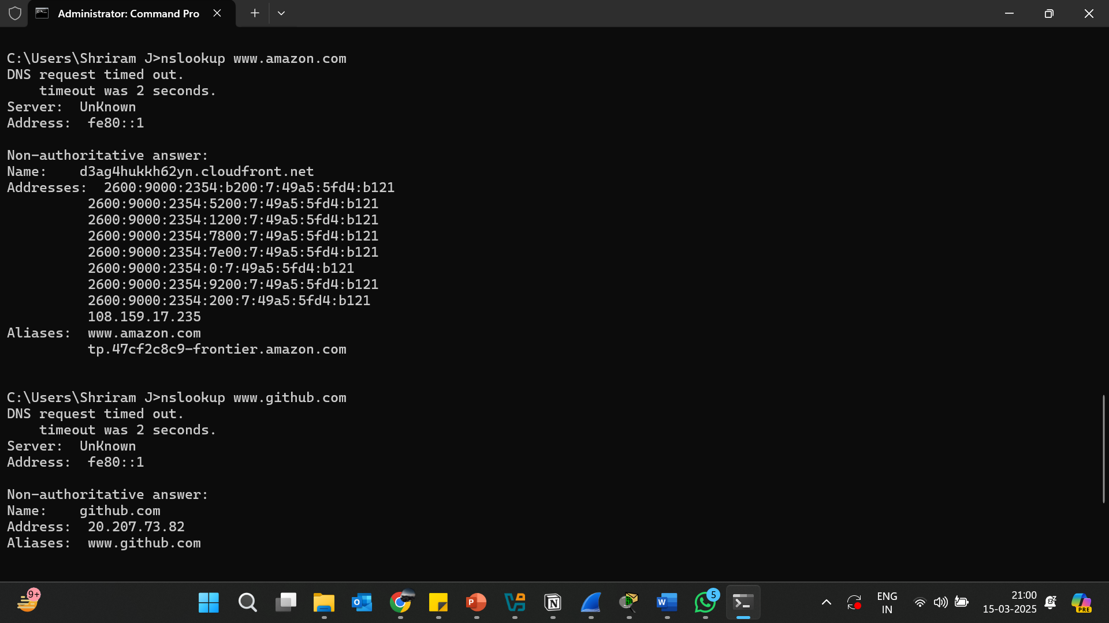

2. Use Wireshark to capture and analyze DNS, TCP, UDP traffic and packet header, packet flow, options and flags

DNS CAPTURE:

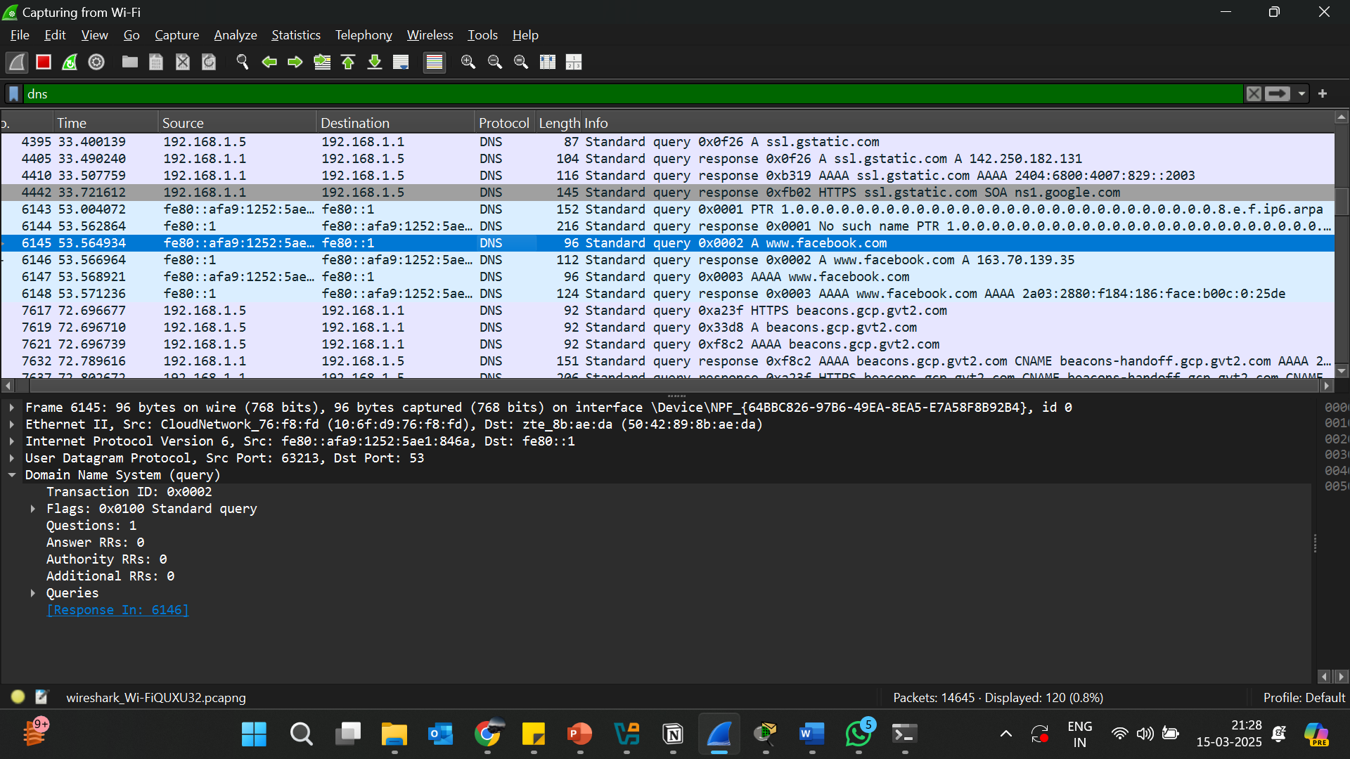

TCP CAPTURE:

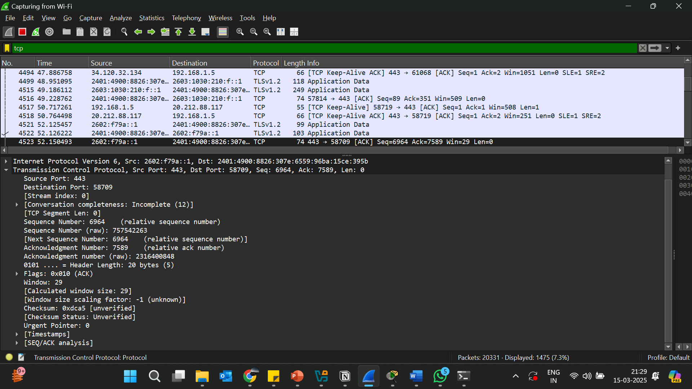

UDP CAPTURE:

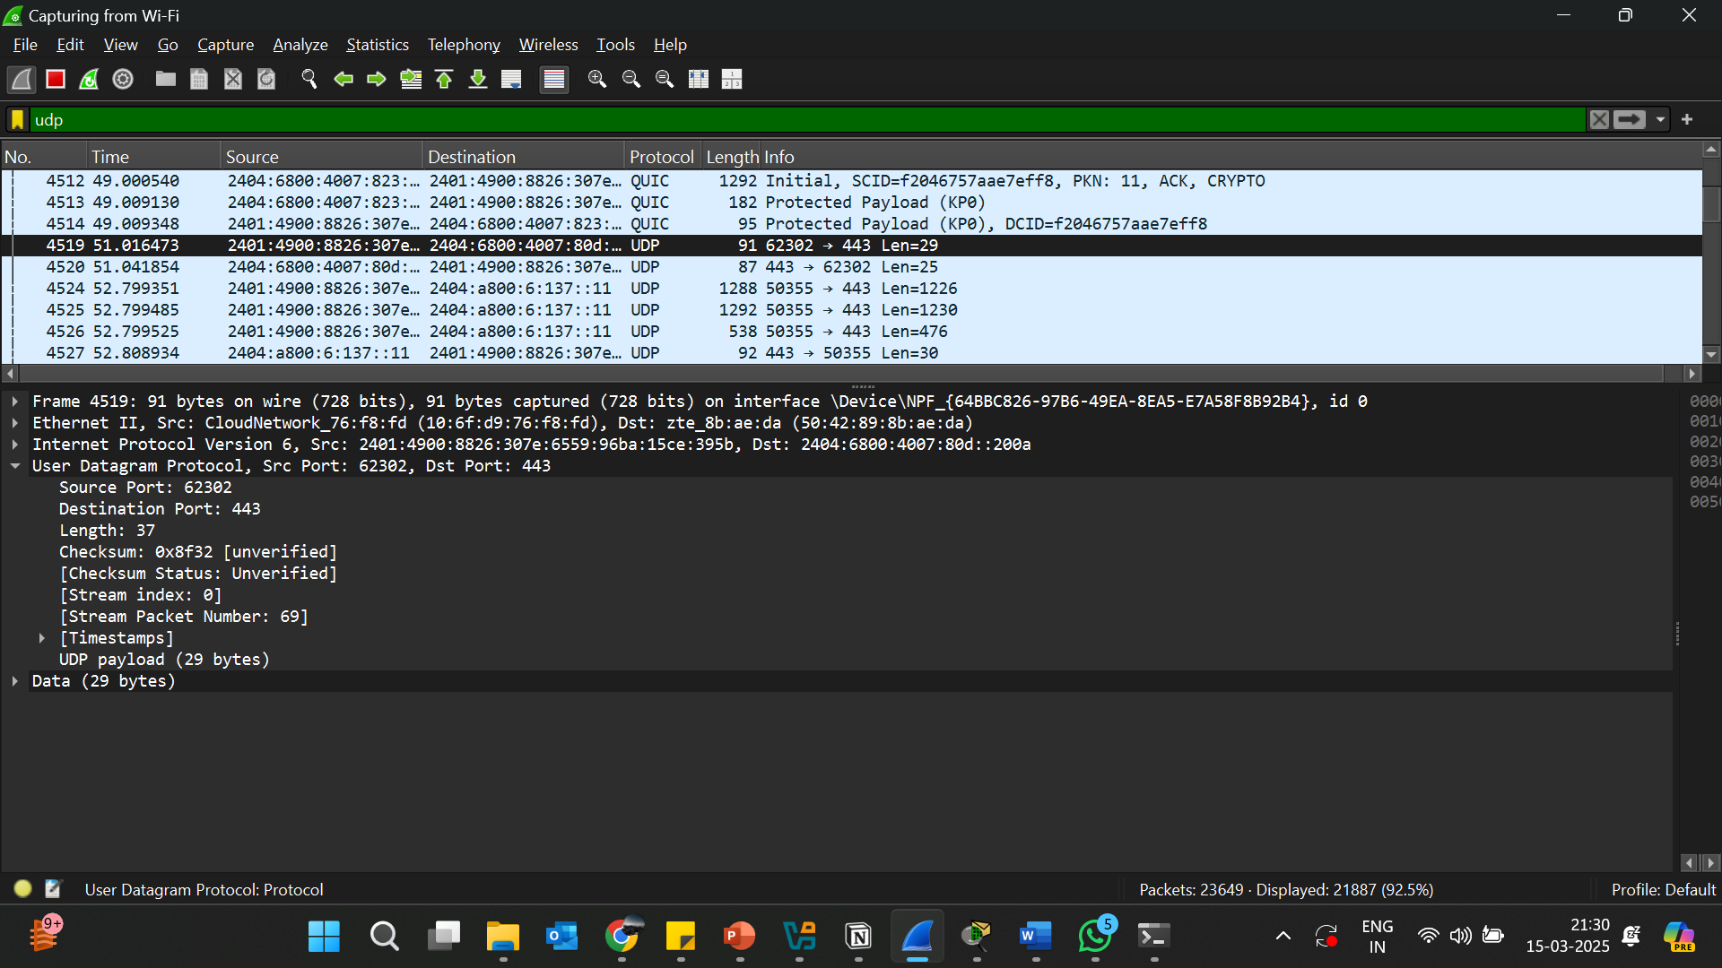

3.Explore traceroute/tracert for different websites eg:google.com and analyse the parameters in the output and explore different options for traceroute command

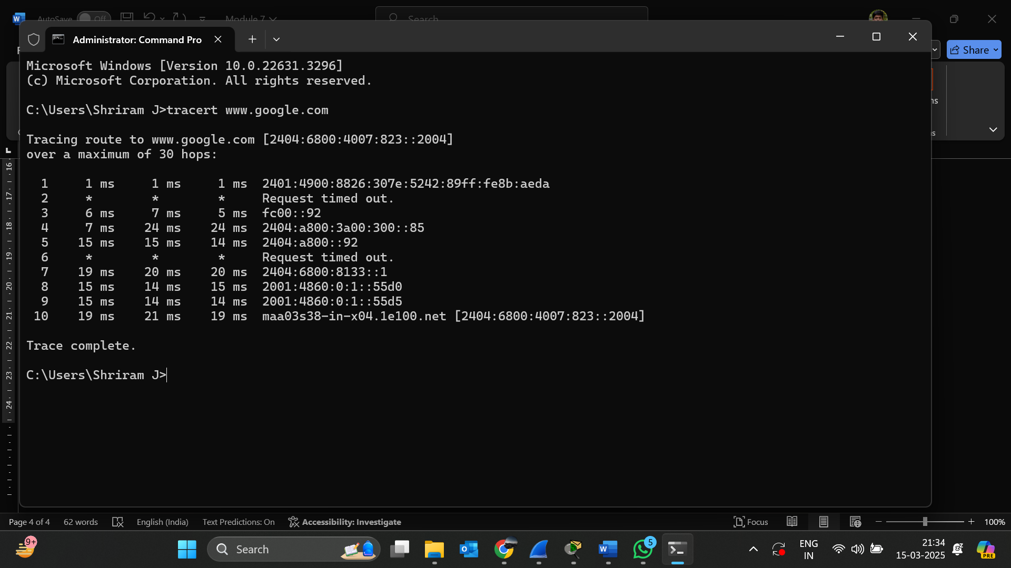

tracert -d www.google.com # Do not resolve hostnames

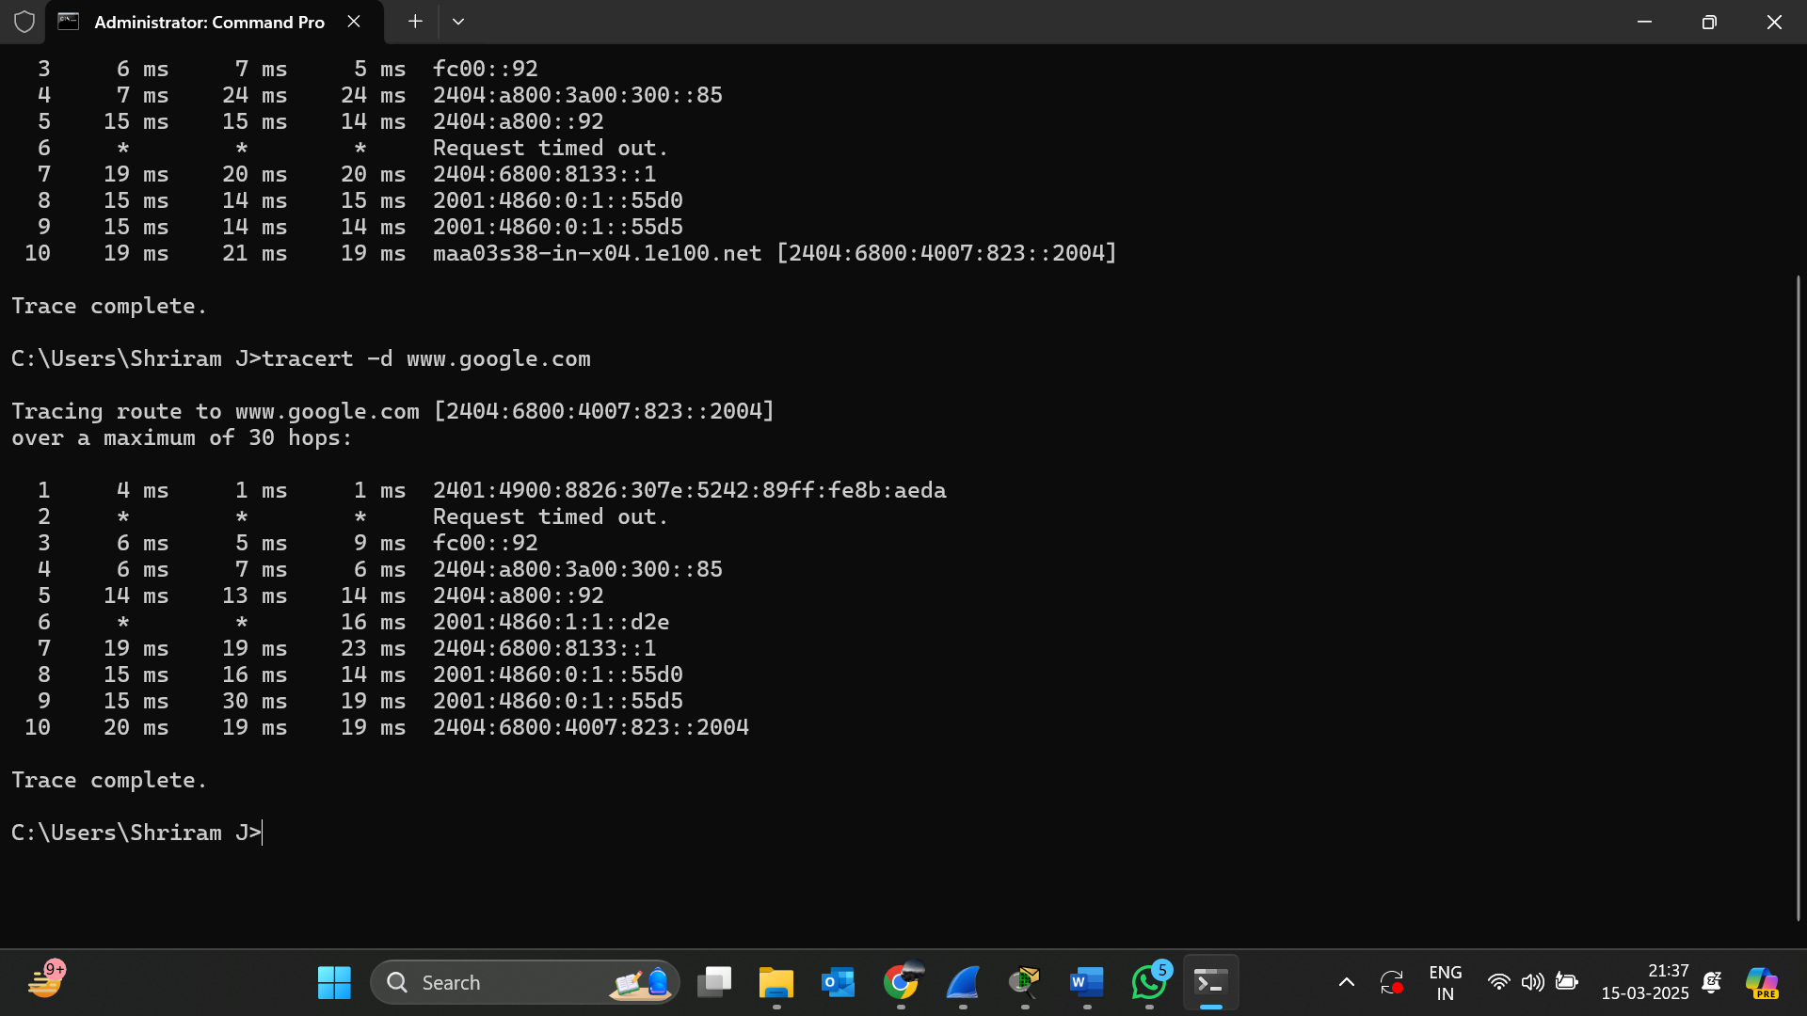

tracert -w 1000 www.google.com # Set timeout to 1000 ms

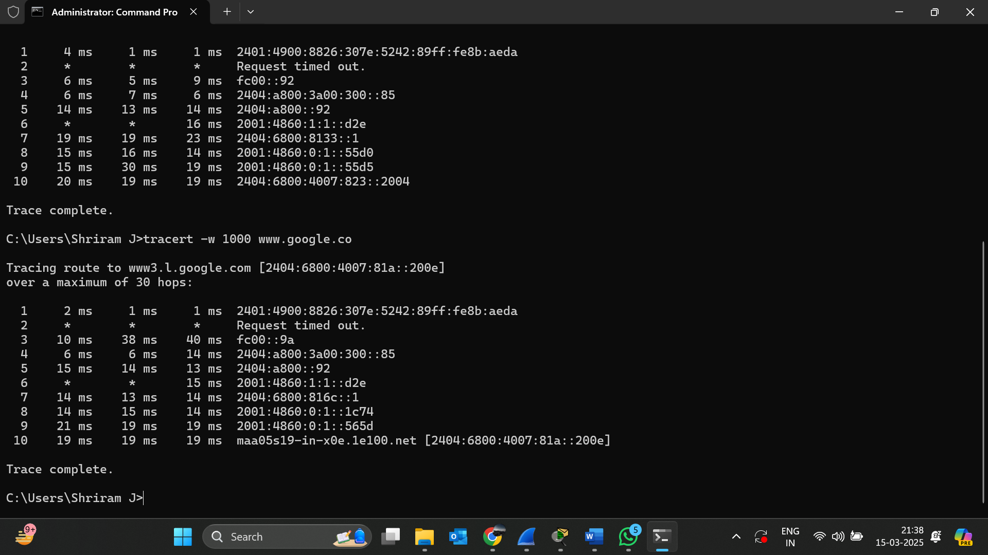

5. Set up trunk ports between switches and try ping between different VLANs.

CONNECTIVITY CHECK BETWEEN DIFFERENT :

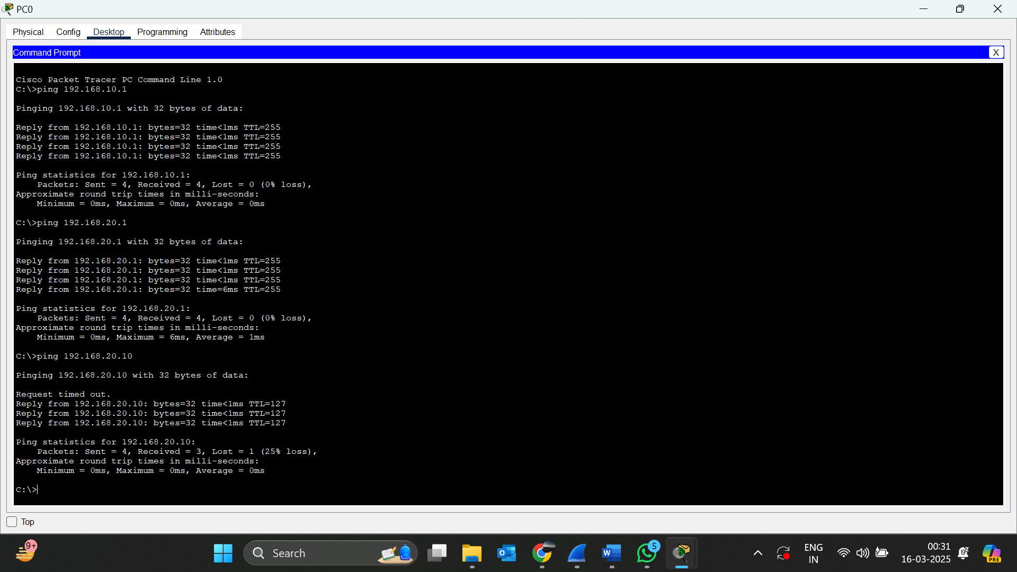

NETWORK TOPOLOGY:

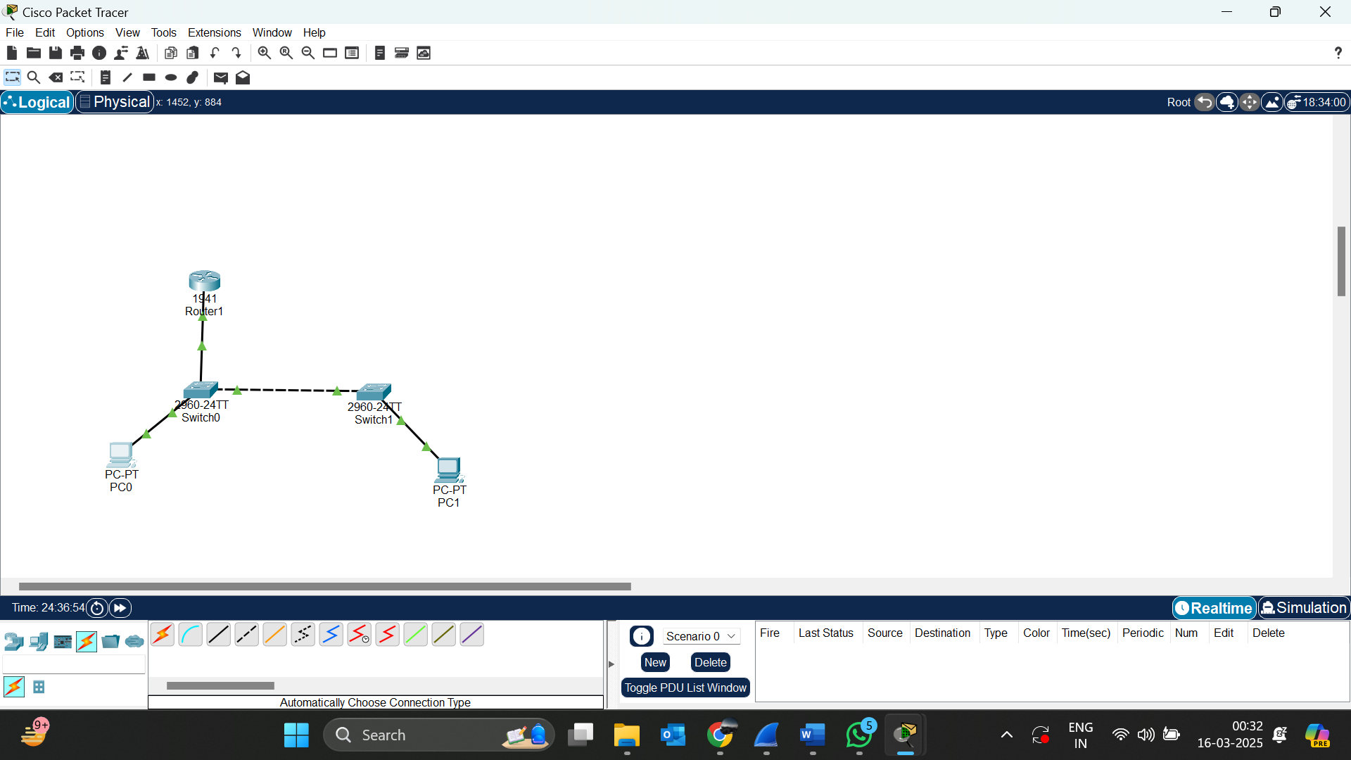

TRUNK PORT CONFIGURATION ON SWITCH 1:

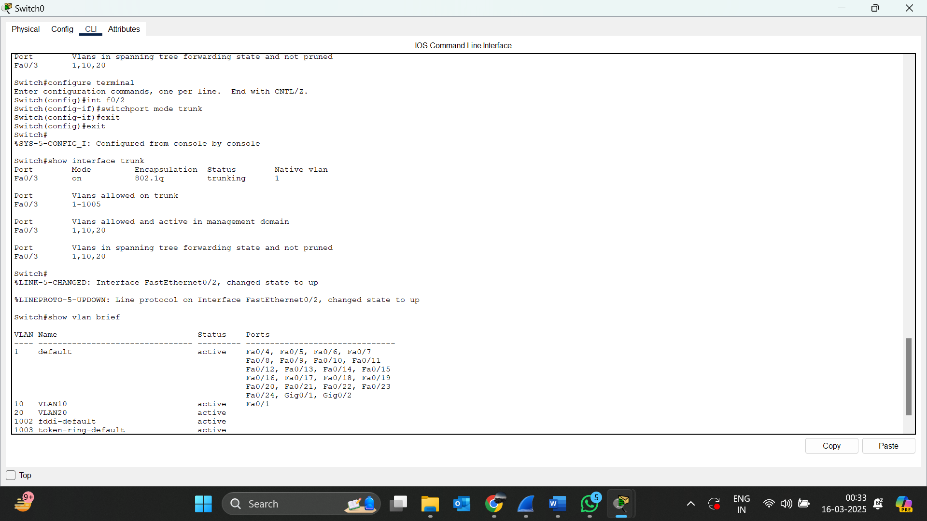

TRUNK PORT CONFIGURATION ON SWITCH 2:

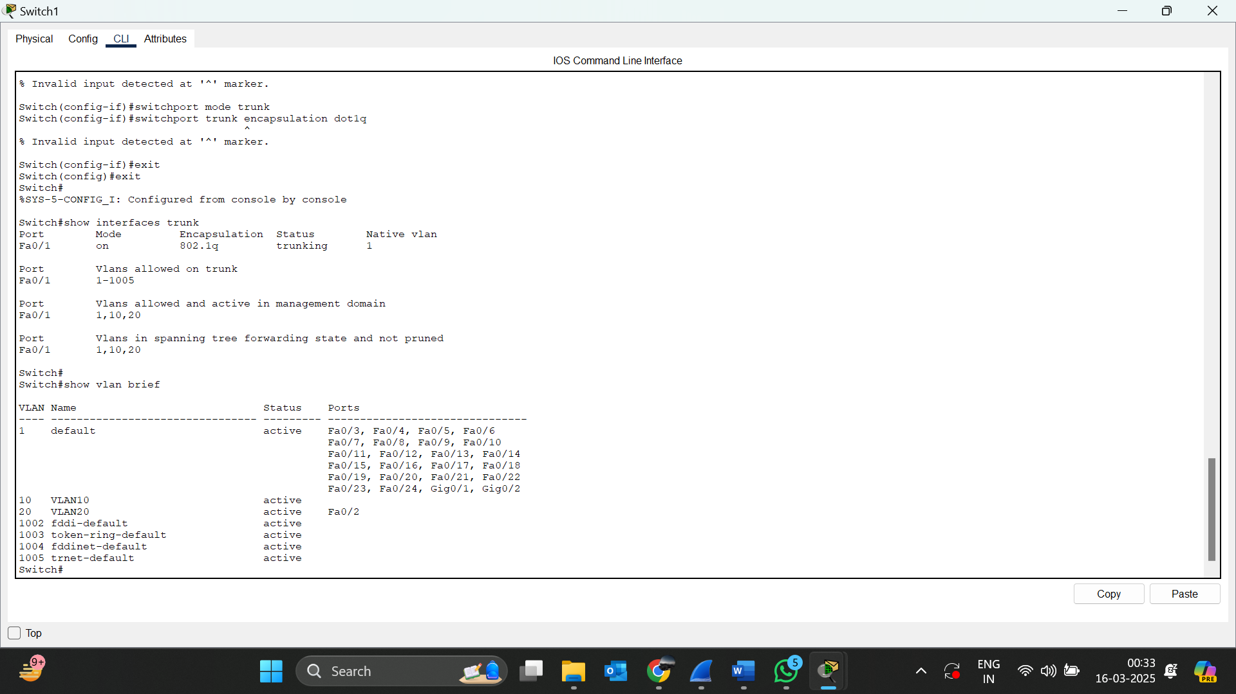

6.Change the native VLAN on a trunk port. Test for VLAN mismatches and troubleshoot

->Changed the native vlan as vlan 99 for both switches and pinged the pc to check pc1 is reachable to pc 2. And the ping works

NETWORK TOPOLOGY:

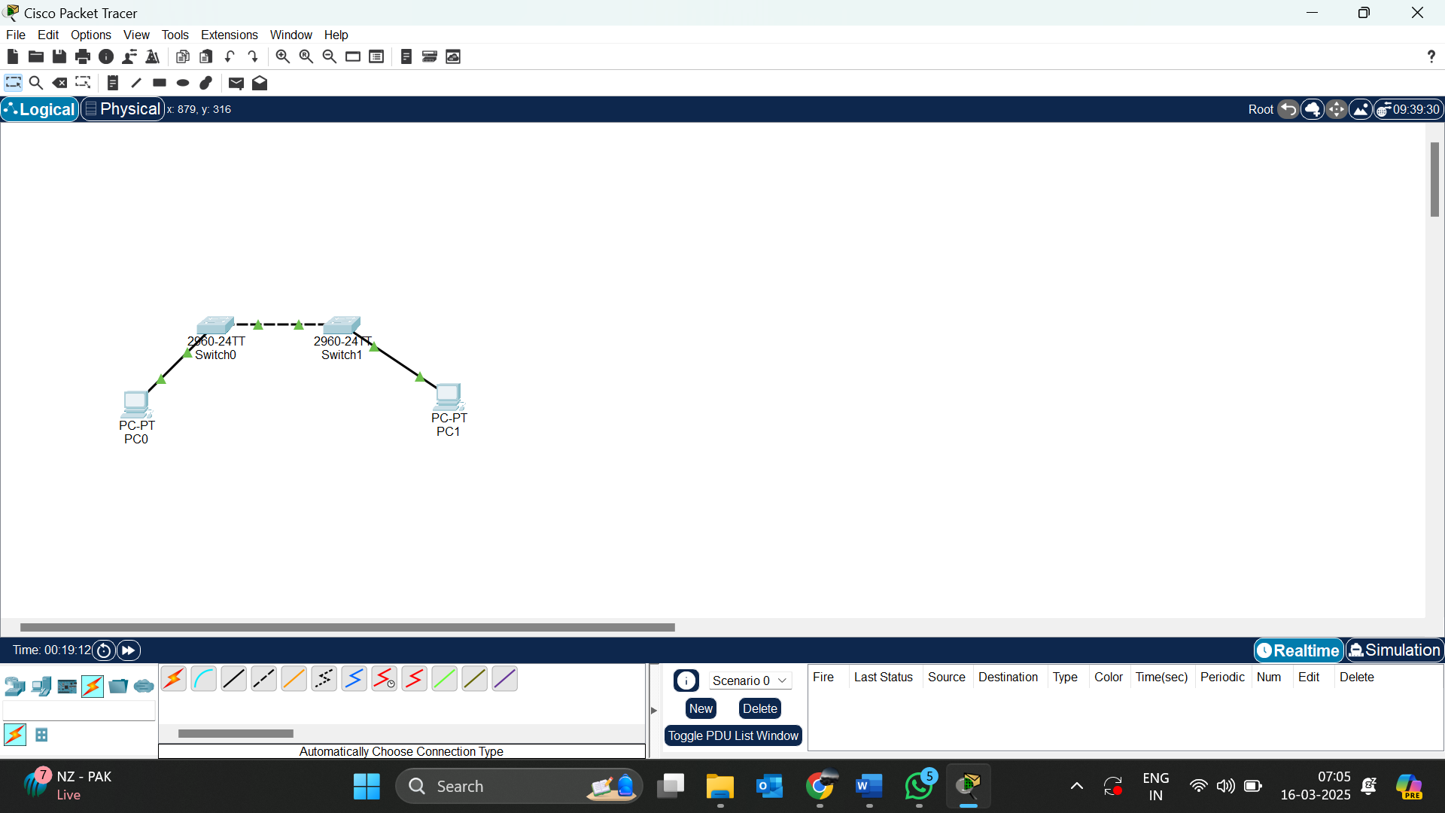

NATIVE VLAN 99 CONFIGURATIONS IN SWITCH 1:

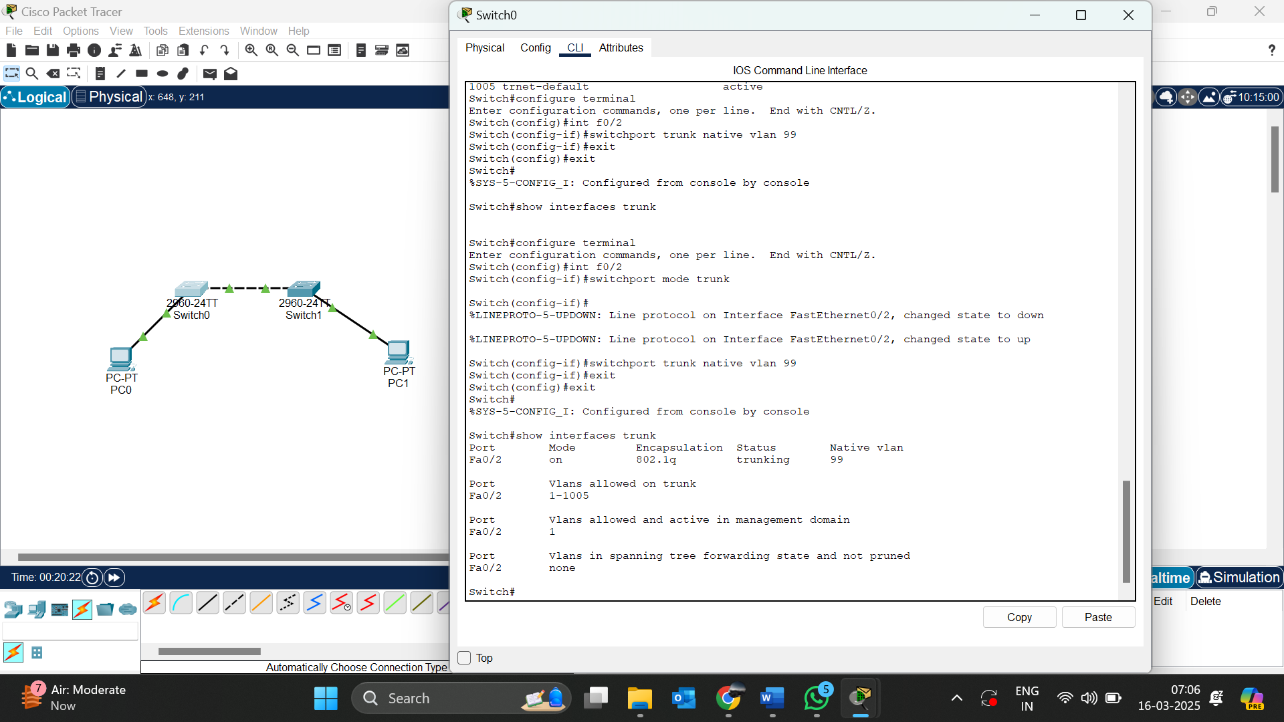

NATIVE VLAN 99 CONFIGURATIONS IN SWITCH 2:

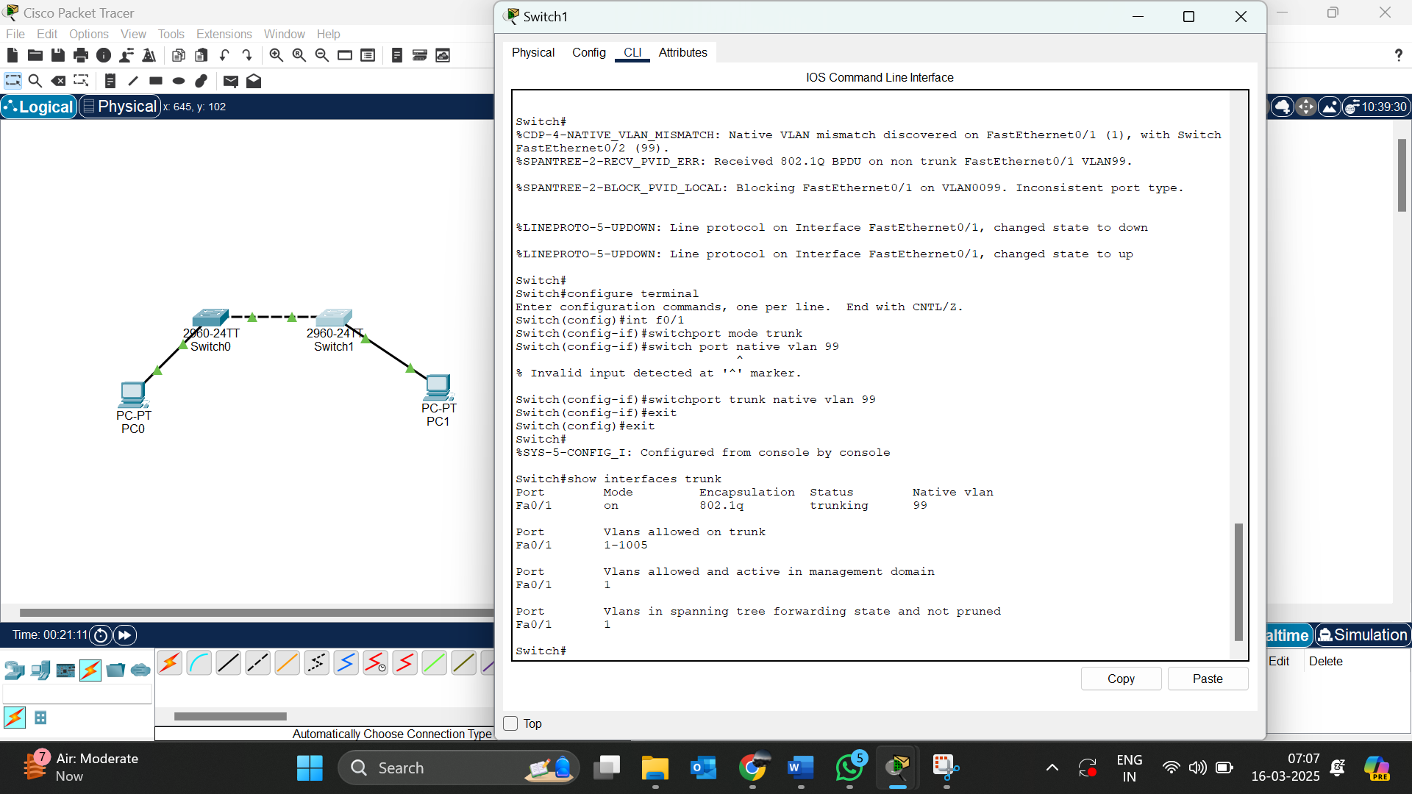

NOW I AM CHANGING THE NATIVE VLAN AS 1 IN SWITCH 1

* As I change the native vlan I am encountering a error as
* %CDP-4-NATIVE_VLAN_MISMATCH: Native VLAN mismatch discovered on FastEthernet0/2 (1), with Switch FastEthernet0/1 (99).
* And the ping is not reachable from pc1 to 2
* 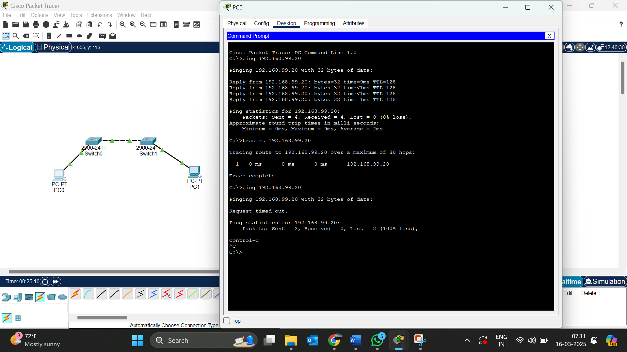

Native vlan mismatch->

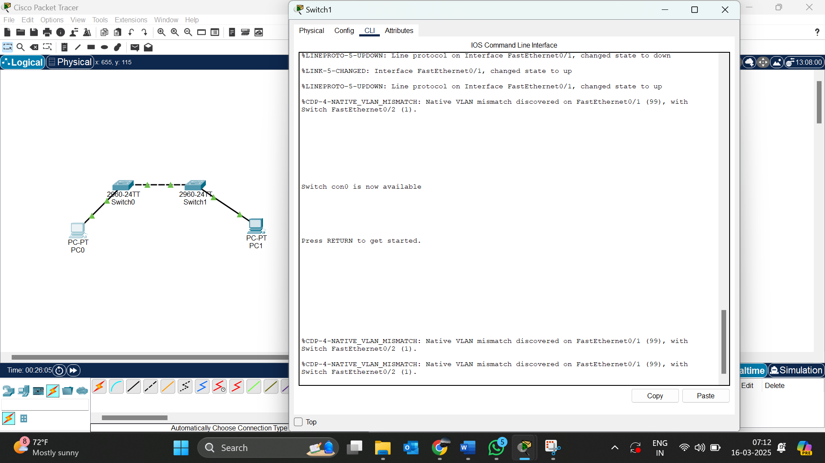

7. Configure a management VLAN and assign an IP address for remote access. Test SSH or Telnet access to the switch.

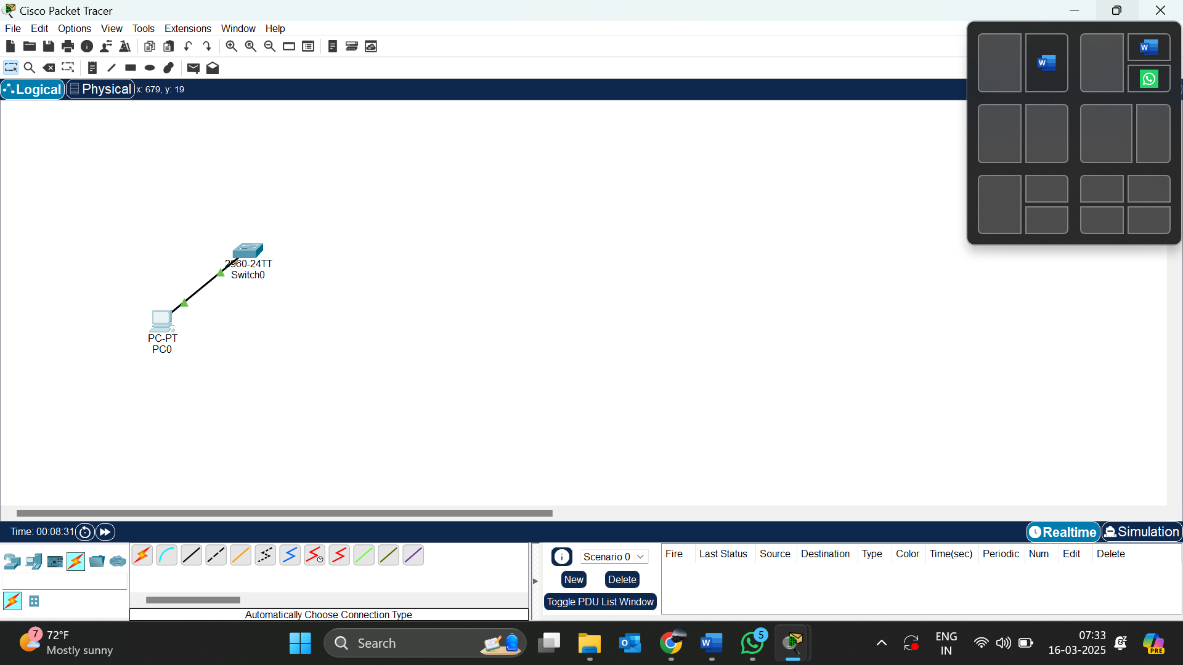

Accessing the switch via telnet:

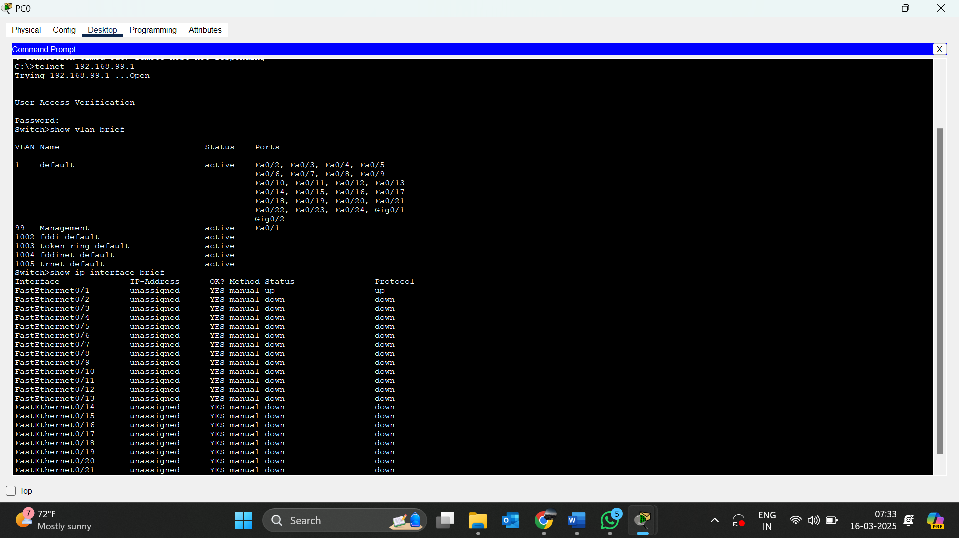

9.You configured VLANs 10 and 20 on your switch and assigned ports to each VLAN. However, devices in VLAN 10 cannot communicate with devices in VLAN 20. Troubleshoot the issue

NETWORK TOPOLOGY:

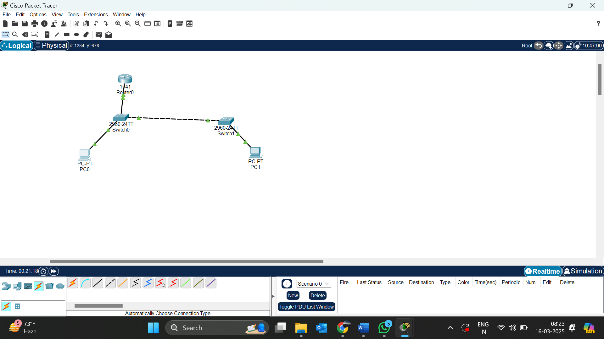

VLAN BRIEF OF SWITCH 1

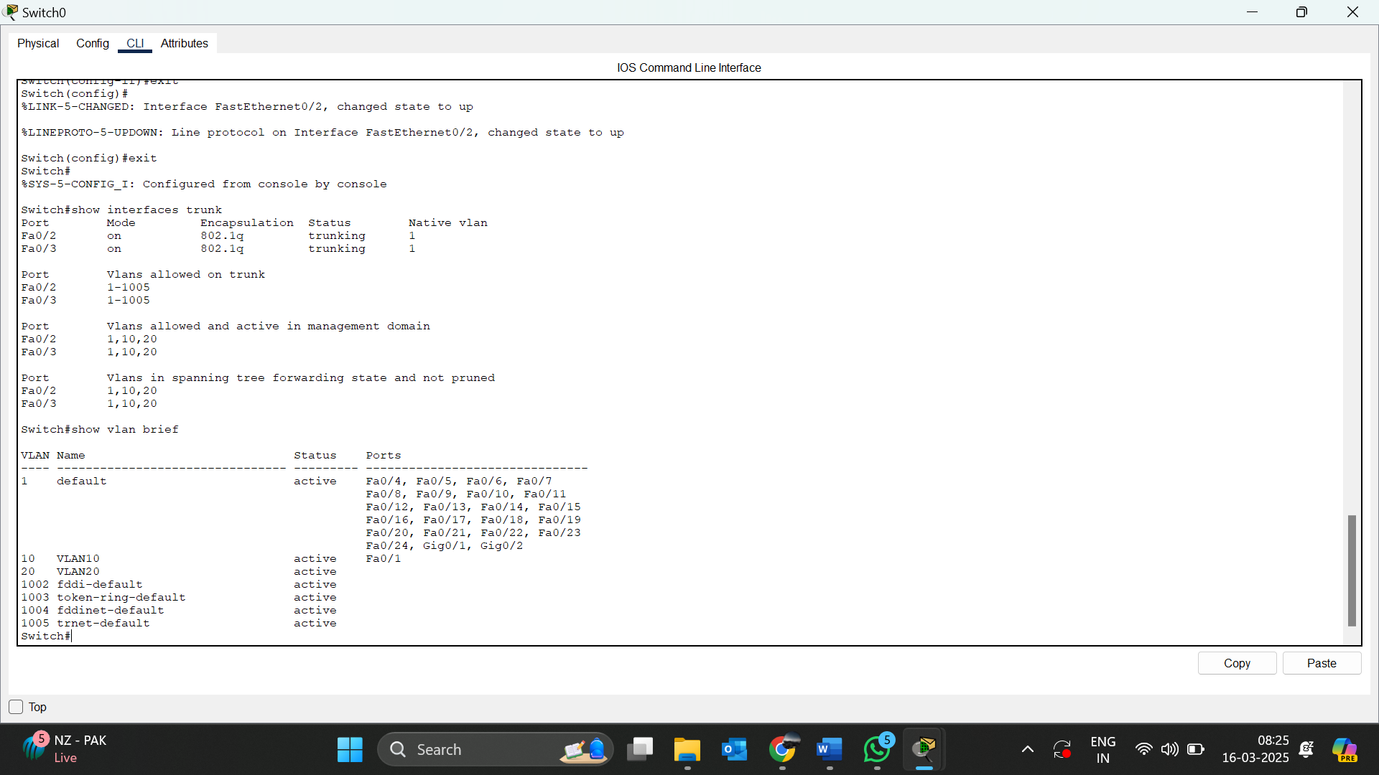

VLAN BRIEF OF SWITCH 1

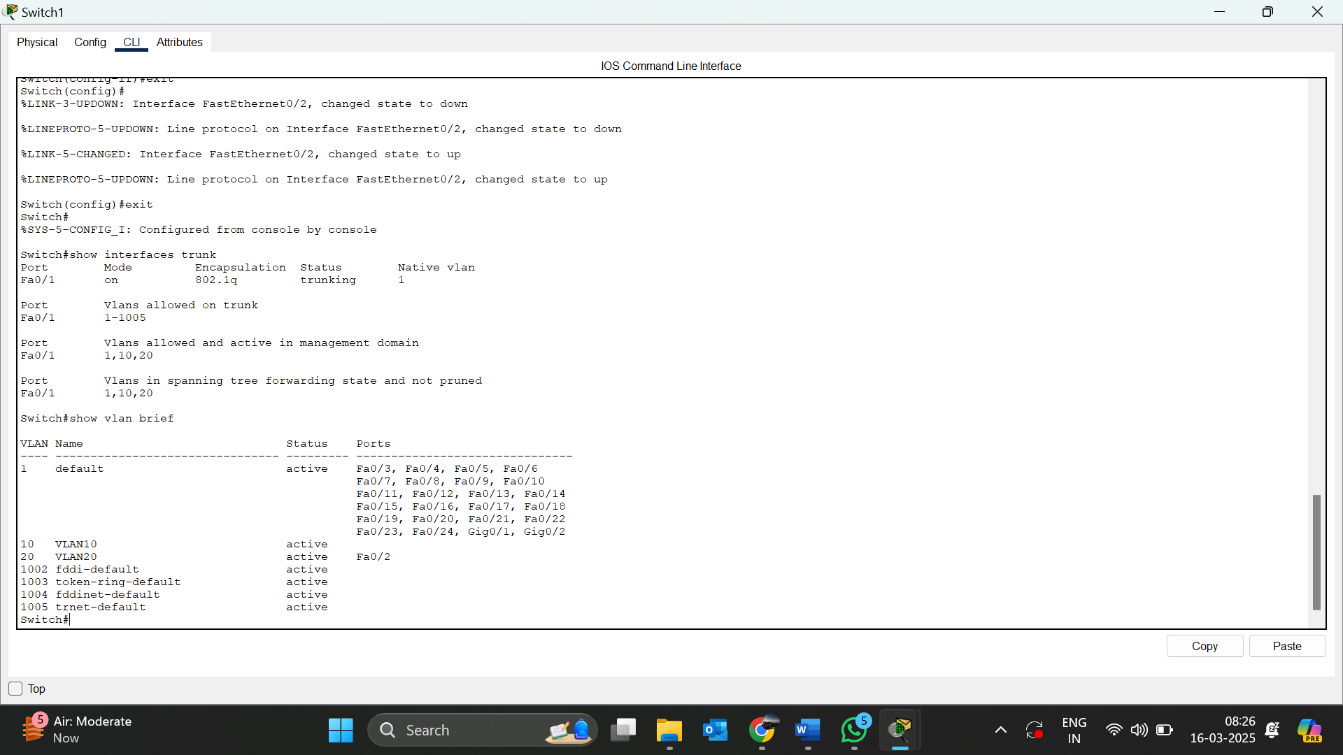

TESTING CONNECTIVITY FROM PC1 TO PC2

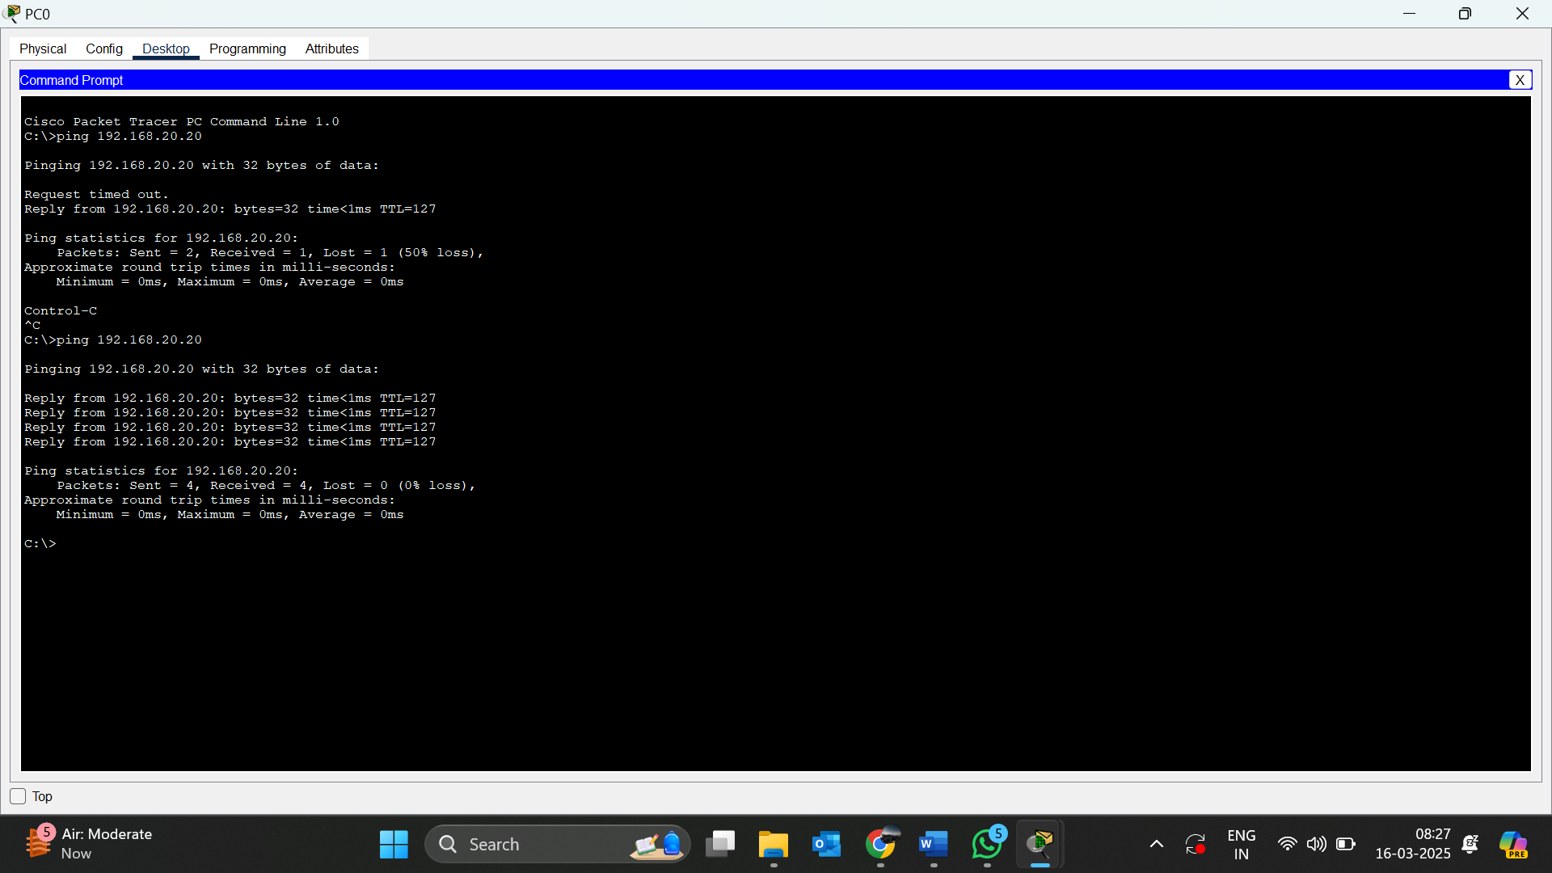

Errors may occur due to:

* Missing VLANs
* Ports Not Assigned to VLANs
* No Inter-VLAN Routing
* Trunk Port Not Configured Properly
* Native VLAN Mismatch (If Using Trunks)
* Missing Default Gateway on Devices

10. Try inter VLAN routing with router

NETWORK TOPOLOGY:



VLAN BRIEF OF SWITCH 1



VLAN BRIEF OF SWITCH 1



TESTING CONNECTIVITY FROM PC1 TO PC2



11. Implement ACLs to restrict traffic based on source and destination ports. Test rules by simulating legitimate and unauthorized traffic.

Network Topology:

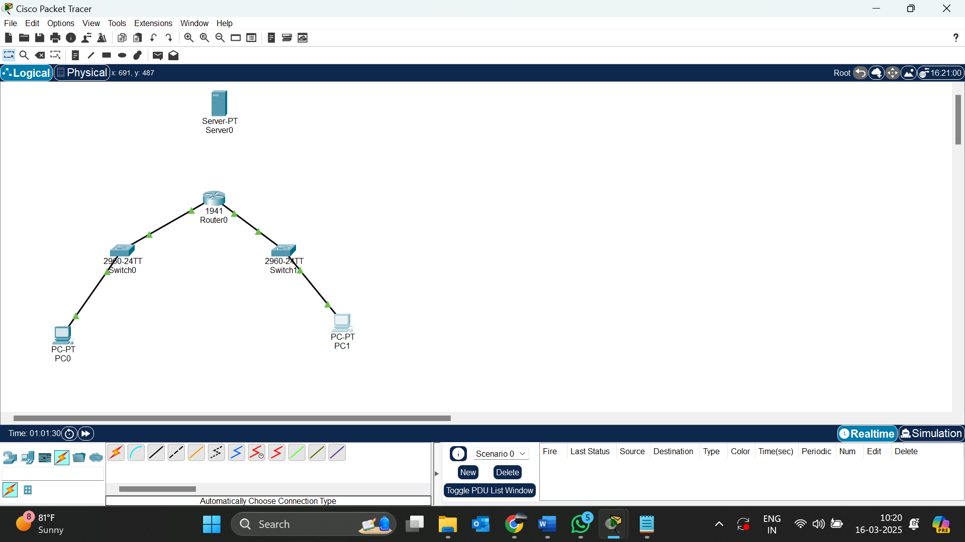

Testing if the ACL works:

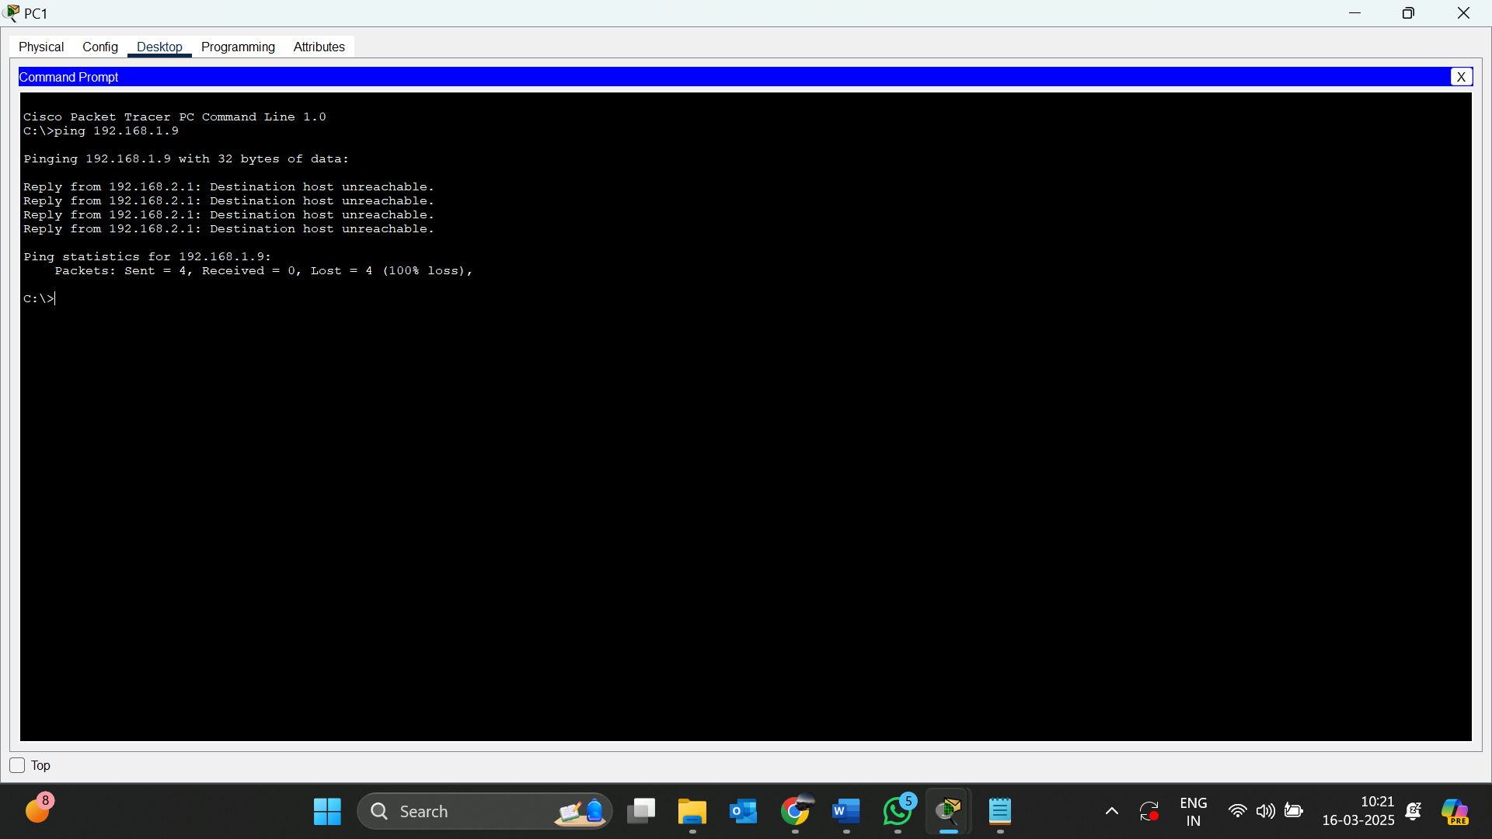

Show access-list in router

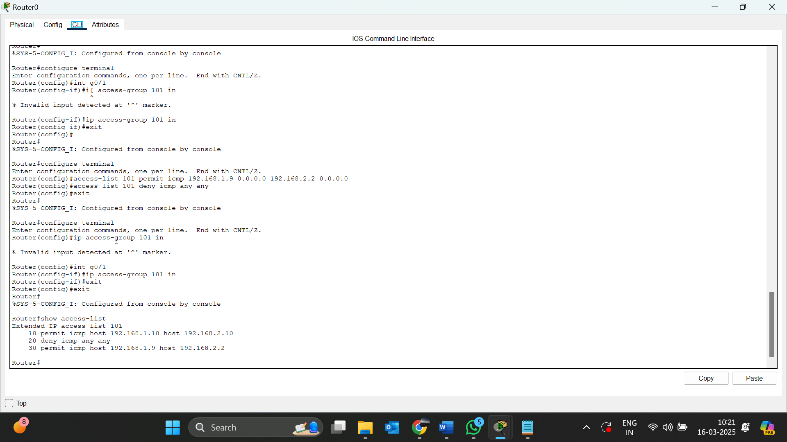

12.Configure a standard Access Control List (ACL) on a router to permit traffic from a specific IP range. Test connectivity to verify the ACL is working as intended

-> we can that the default gateway is block from the pc 2

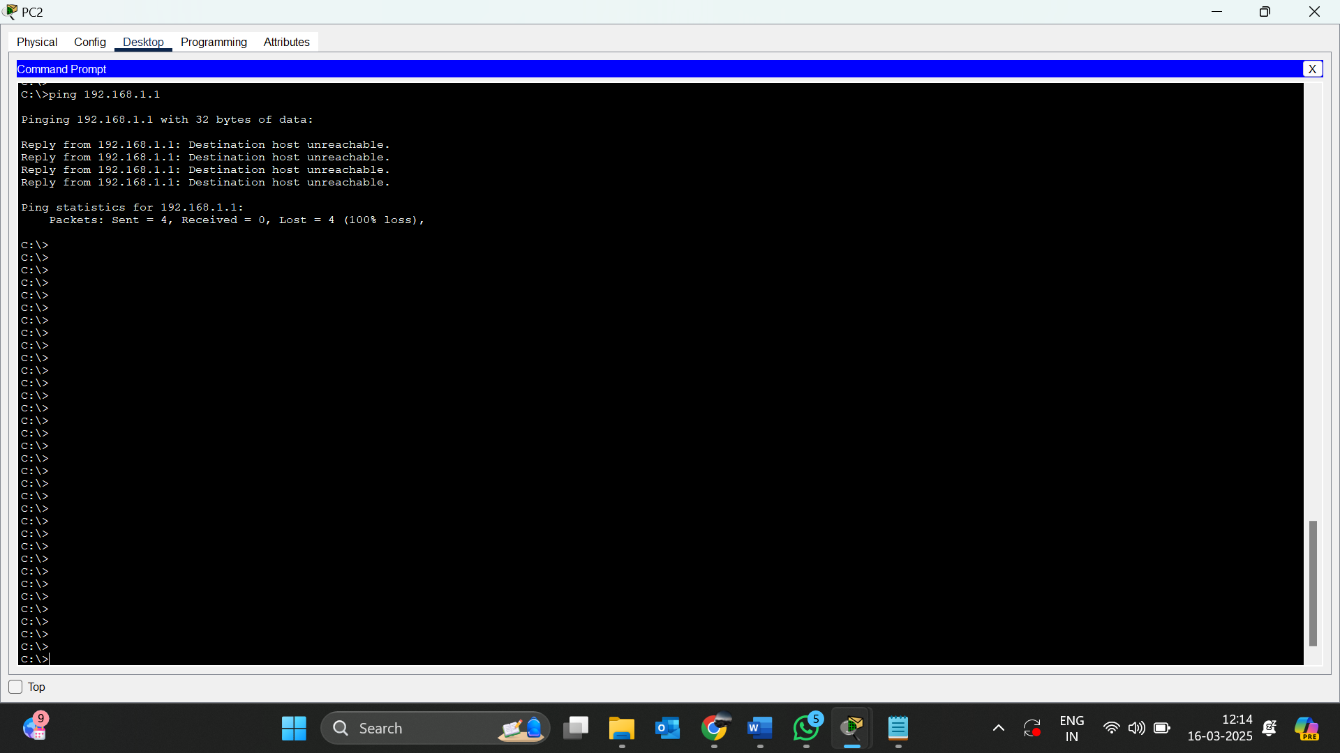

Network topology:

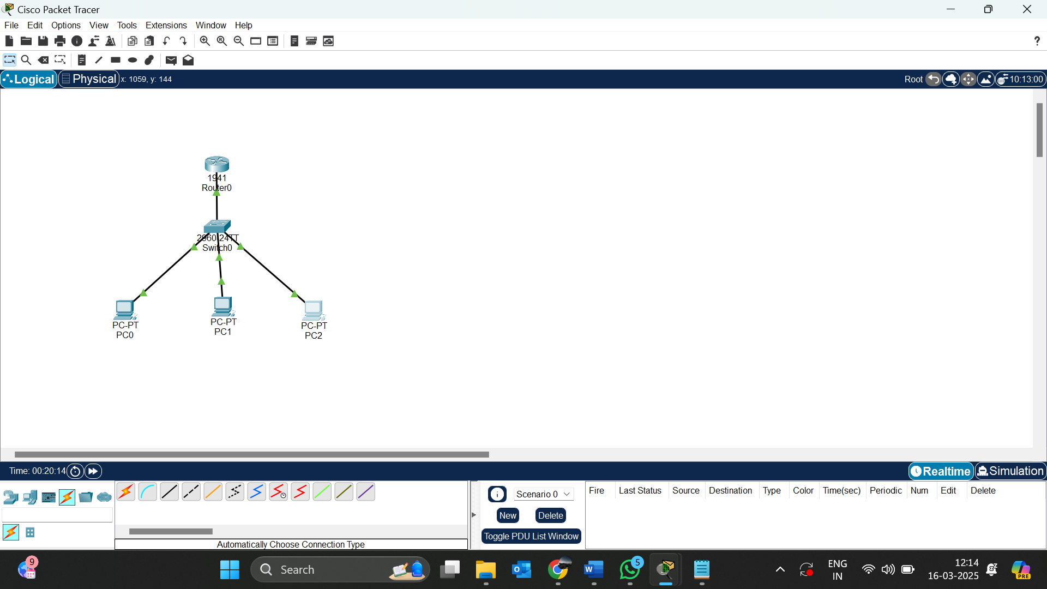

Access list of the Router:

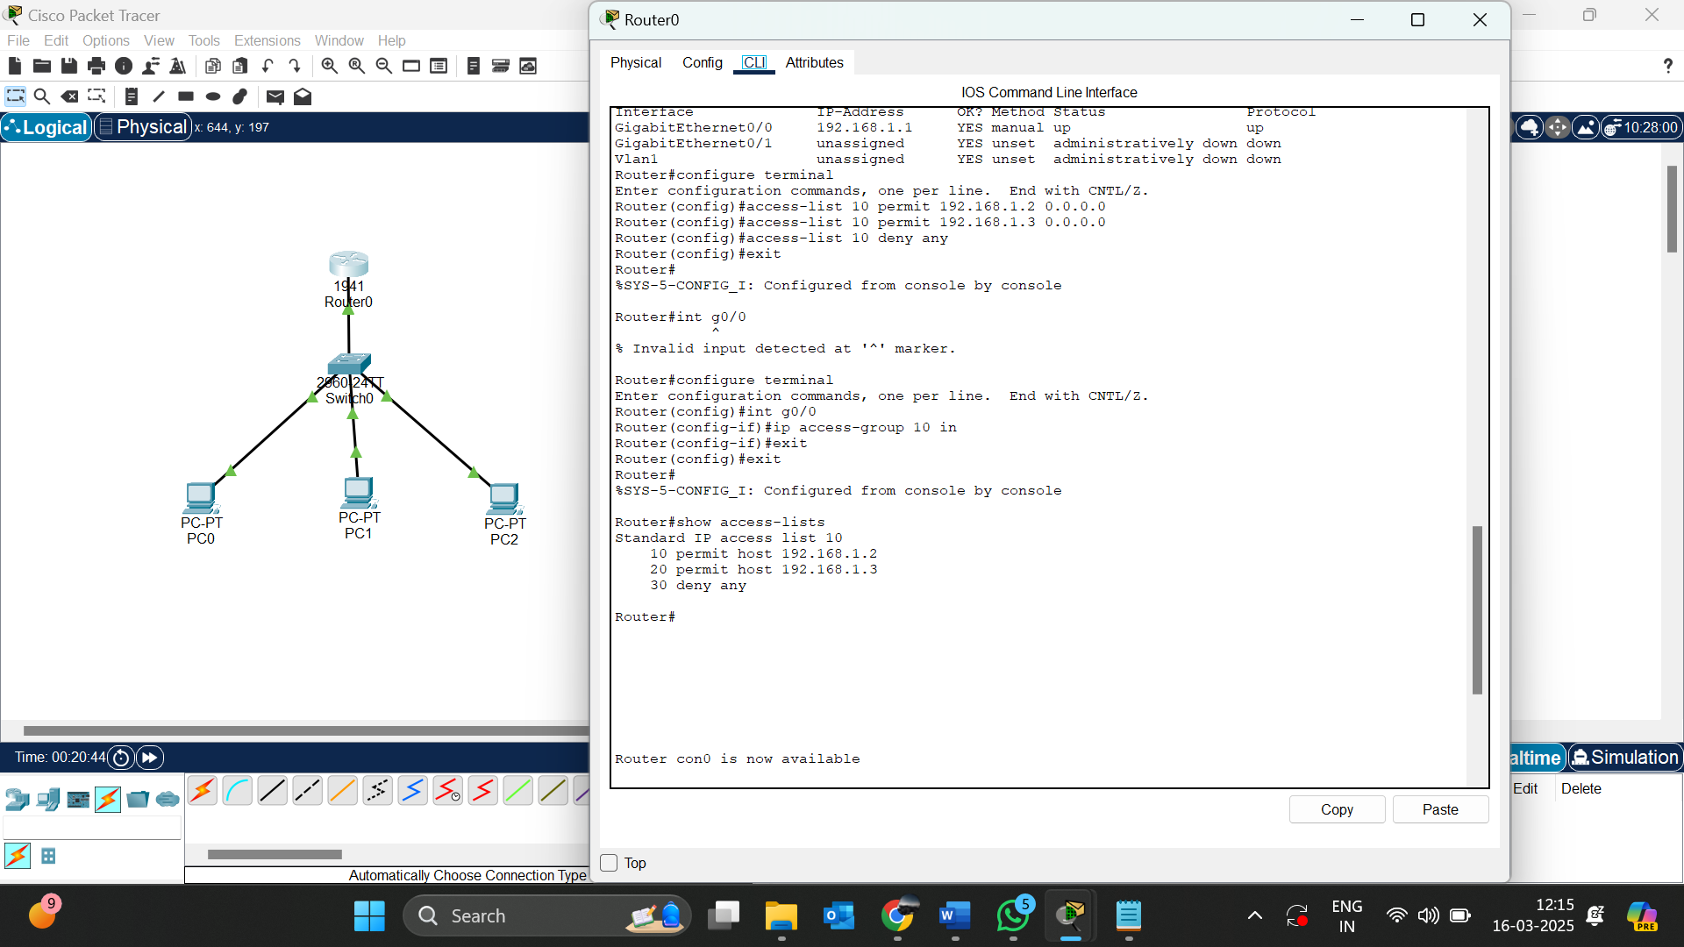

13. Create an extended ACL to block specific applications, such as HTTP or FTP traffic. Test the ACL rules by attempting to access blocked services.

NETWORK TOPOLOGY:

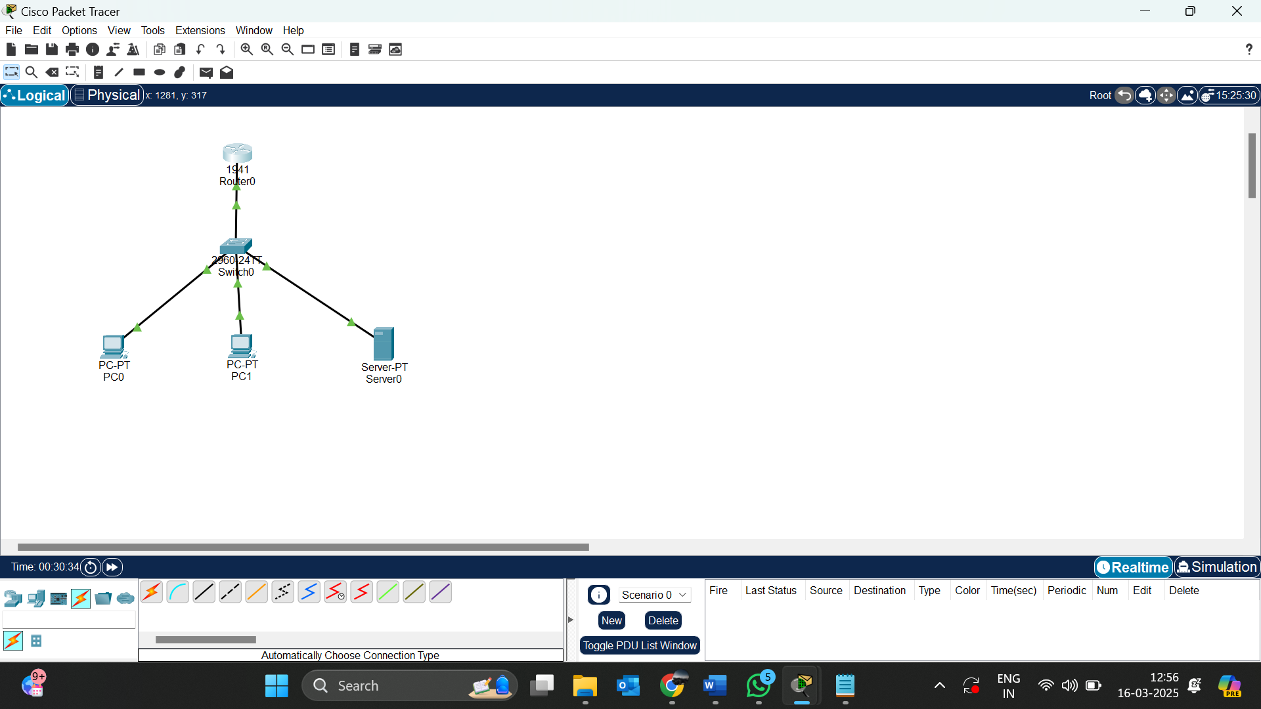

Access-list of the router:

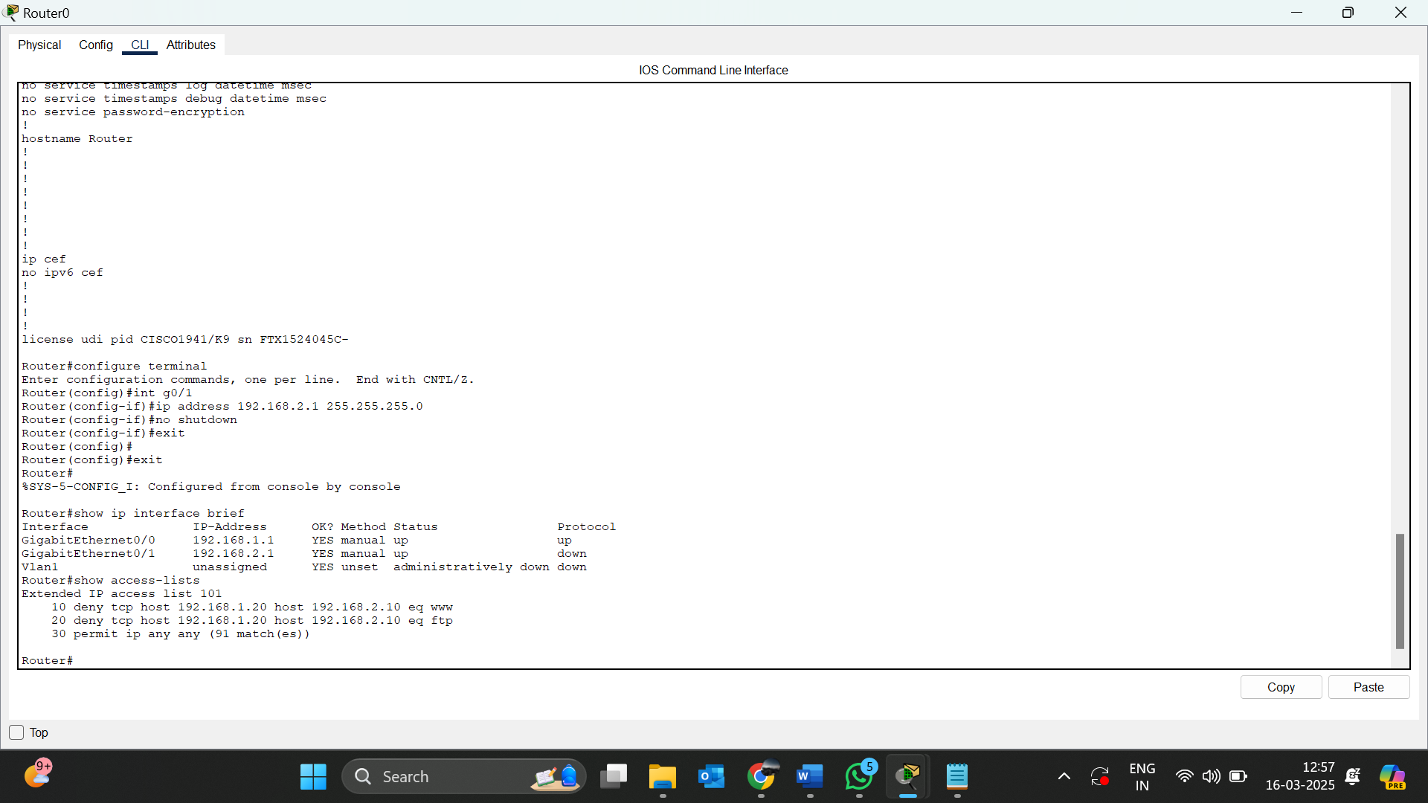

14.Try static nat dynamic nat and pat

**-> Static NAT Configuration** (One-to-One Mapping)

enable

configure terminal

interface GigabitEthernet0/0

ip address 192.168.1.1 255.255.255.0

ip nat inside

exit

interface GigabitEthernet0/1

ip address 203.0.113.1 255.255.255.0

ip nat outside

exit

ip nat inside source static 192.168.1.10 203.0.113.10

exit

* **Dynamic NAT Configuration** (Private Pool to Public IP Range):

enable

configure terminal

ip nat pool MY_POOL 203.0.113.100 203.0.113.110 netmask 255.255.255.0

access-list 1 permit 192.168.1.0 0.0.0.255

ip nat inside source list 1 pool MY_POOL

exit

* **PAT (Port Address Translation) Configuration** (Many-to-One)

enable

configure terminal

access-list 1 permit 192.168.1.0 0.0.0.255

ip nat inside source list 1 interface GigabitEthernet0/1 overload

exit